## First program: Blink

<https://www.youtube.com/watch?v=IrFAlhwRNtU>

This is the first program that we will experiment with together! This sequence of instructions will switch an LED connected to pin 13 of the Arduino, on and off, once every second.

**Arduino or simulator**

In the Arduino IDE, the program Blink can be found in *File→ Examples→ 01.Basics→ Blink*. For the Arduino simulator, copy and paste the code below:

// Number of the pin connected to the LED:  
int led = 13;

// the function runs once when you press reset or power the board

void **setup**() {

// initialize digital pin 'led' as an output.

  pinMode(led, OUTPUT);

}

// this code runs over and over again as long as there is power

void **loop**() {

  digitalWrite(led, HIGH); // light LED (send 5V to the pin)

  delay(1000); // wait 1000ms = 1s

  digitalWrite(led, LOW); // turn off LED (0V to the pin)

  delay(1000); // wait another second

}

**Assembly**

**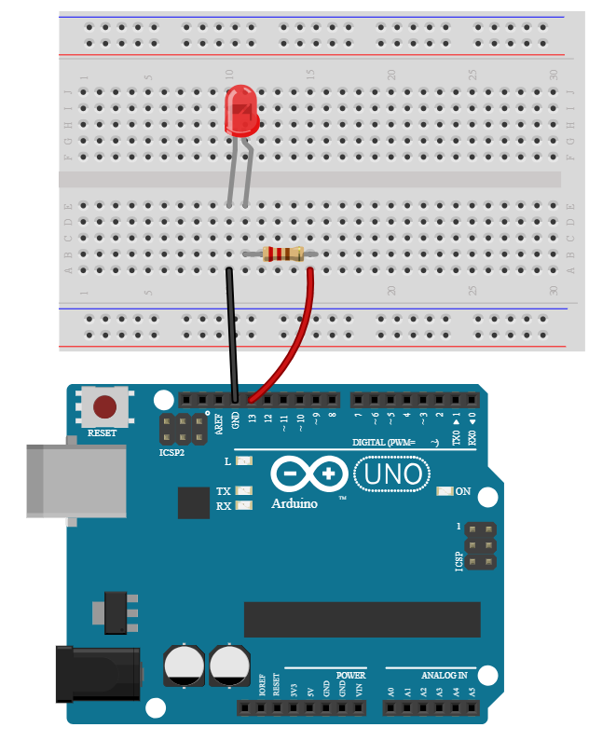**

Remember that (unlike regular light bulbs) LEDs only work when connected in a particular direction – check that the **-** (**minus**) tab is connected to the **GND** (**ground**) pin of your Arduino. To remember this, just think: the shorter leg is the - (minus) leg. The other leg **+** (**plus**) must be connected to **pin 13** which receives the current:

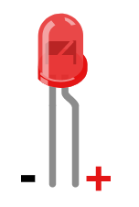

**Instructions**

At the end of each program, we will explain all the new code you used. As this is our first program, we have a few things to go over! (do not hesitate to click on the links below to reach the Arduino reference)

In this program, we have:

* The code:
* **Declaring a variable:** we want to create a new variable, give it a name, and store a number in it.

int led = 13;

In this case, we have a **variable** called led which is going to be a number (the key word **int** stands for integer, which means a whole number) and we set it equal to the value 13.

* **Blocks of code**: [**setup**](http://www.mon-club-elec.fr/pmwiki_reference_arduino/pmwiki.php?n=Main.Setup) contains all the instructions that are executed when the program starts. La fonction [**setup**](http://www.mon-club-elec.fr/pmwiki_reference_arduino/pmwiki.php?n=Main.Setup) is only executed once, when the Arduino board is switched on or when you press the reset button. [**loop**](http://www.mon-club-elec.fr/pmwiki_reference_arduino/pmwiki.php?n=Main.Loop) contains instructions which are executed over and over again as long as the Arduino has power.

The two functions / blocks of code inside **setup** and **loop**are necessary for every Arduino programme, even if they're empty (i.e. even if they don't contain instructions) - which would look like this:

void **setup**() { }  
void **loop**() { }

* **Functions**: are instructions that allow you to execute one or more actions. They are defined with:
  + **A name**: the name of the function
  + **One or two inputs**: variables passed into the function are called **parameters** or **arguments**. These arguments are put in brackets after the function name.
  + **Outputs**: the result of the function, which you might want to store in a variable.

Let's take the following function as an example:

digitalWrite(led, HIGH);

In this case, the name of the function is [digitalWrite](http://www.mon-club-elec.fr/pmwiki_reference_arduino/pmwiki.php?n=Main.DigitalWrite" \o "digitalWrite" \t "_blank). We pass two parameters into the function: ledand HIGH. [digitalWrite](http://www.mon-club-elec.fr/pmwiki_reference_arduino/pmwiki.php?n=Main.DigitalWrite" \o "digitalWrite" \t "_blank) doesn't have an output here - what it does is write to the Arduino pin named in the first input, the value named in the second input. When the second argument is HIGH, we therefore turn on the LED. When we want to turn off the LED, we set the second argument to LOW.

Other functions we have in the *Blink* script:

* [pinMode](http://www.mon-club-elec.fr/pmwiki_reference_arduino/pmwiki.php?n=Main.PinMode) sets the specified pin to be an input our output (in this case we pass OUTPUT as the second parameter:

pinMode(led, OUTPUT);

* [delay](http://www.mon-club-elec.fr/pmwiki_reference_arduino/pmwiki.php?n=Main.PinMode) pauses the program for a number of milliseconds (thousanths of a second) which is passed as its parameter:

delay(1000);